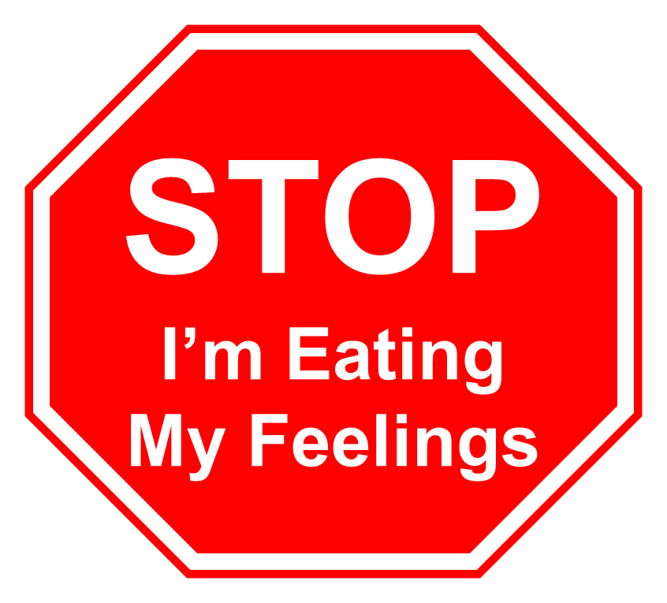
The 4 Flavors of
Compulsive Overeating

Tory Butterworth, PhD
STOP Eating My Feelings
www.torybutterworth.com
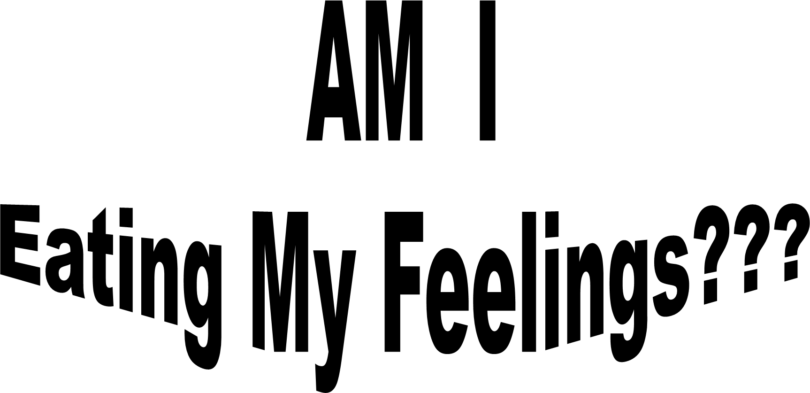

“I’ve been told I eat my feelings. Sure, I’ll buy that.
But what does that really mean and, more importantly, how do I stop?”
Workshop Participant

How many times have you lost those unwanted pounds, only to gain them back again, sometimes more than you lost? Maybe the problem doesn’t lie in a lack of self-control, or even the diet or exercise programs you’ve tried. It could be because you’re eating your feelings.
Are you intrigued by the phrase, “eating your feelings,” but don’t really know what it means or what you can do about it? In the past, “eating your feelings” has been treated as “one size fits all.” But, really, there are at least four different ways you might be eating your feelings. This ebook provides a description of each of these eating flavors, and what’s necessary to change these patterns of emotions and behavior.
In this ebook you will learn:
- How do I know I am eating my feelings?
- 4 ways of eating my feelings:
  - Sampling and Grazing
  - Traumatized overeating
  - Overworked overeating
  - Picky overeating
- How do I STOP?

What are some signs I might be eating my feelings?
Many people eat for emotional reasons every once in a while. If you do it rarely (say, less than once a month) and stop after only a small portion (half a cup of ice cream, a handful of nachos) it may not be a problem for you. But, if you find yourself eating your feelings more than once a week or consuming large amounts of food when you do, this behavior could be a problem you’d like to address. You may be eating your feelings if you find yourself:
- Eating large quantities of food when not physically hungry,

- Eating continually throughout the day, without planned mealtimes,

- Eating much more rapidly than normal,

- Eating until you feel uncomfortably full,

- Feeling out of control when you eat or as though you can’t stop,

- Eating alone because you are embarrassed,

- Feeling disgusted with yourself, depressed, or guilty after eating,

- Becoming preoccupied with your eating, weight, or shape to the point that it interferes with your life (your relationships, your work, or having fun),

- Experiencing significant distress over your eating and how it affects your life.
Eating your feelings can be painful. Studies have shown that people who eat their feelings are more likely to:
- Evaluate themselves and their self-worth by their weight and shape,

- Allow their weight or shape to interfere with feeling good,

- Let their discomfort over their weight and shape interfere with their relationships with other people,

- Allow their discomfort over their weight and shape interfere with their work.

Most people who eat their feelings have made repeated efforts to lose weight, only to gain it back again. On average, they:
- Have been on diets for more than half of their adult life,

- Have gained and lost 20 pounds, five or more times.

Eating your feelings can be part of a larger pattern of mental health. Compared with those who are overweight but don’t eat their feelings, people who eat their feelings are more likely to:
- Have a history of depression,

- Have a history of alcohol or drug abuse,

- Have a history of sexual abuse,

- Have seen a mental health professional for help.
If this description of eating your feelings fits you, there’s good news. You can change this pattern in your life.
Rather than using eating as a way to suppress or deny your feelings, your eating patterns can become a way to explore and heal old wounds. Wouldn’t it be nice, if instead of beating yourself up every time you eat too much, you could explore where that appetite came from with curiosity and interest, or maybe even a sense of hope?
In the past, a “one size fits all” method had been used to address eating your feelings. This can confuse compulsive overeaters, because the reasons a person overeats may vary from one person to the next. Different solutions are needed to change each of these unique patterns. Some of you eat your feelings in more than one way. In order to stop, you will need to address each of the ways you eat your feelings.
Sampling and grazing
If you are a sampler or grazer, you eat continuously all day, not knowing exactly what you are looking for, but hoping once you find it, you’ll be satisfied. You may be eating because it's there, eating to avoid things you don't want to face, eating because you're bored, or eating because you're uncertain. Perhaps you have a hard time telling when you're hungry, so you create a rule: when in doubt, eat.
When you’re sampling food you may not notice how much you eat, because you’ll try a little bit of something, and then just a little bit of something else, and on and on. Over the course of a day, a week, a year, all those little bits add up. Often sampling (“I’ll just take a little bit of this”) turns to grazing (“Maybe I’ll just have a little bit more”) or even a clean sweep (“While I’m at it, why not finish this off?”) In extreme cases, this can become a habit that goes on all day, every day.
Sampling and grazing often happens during large, unstructured blocks of time, such as over a weekend when nothing has been scheduled. This is because, as a sampler and grazer, you have a hard time identifying, in any given moment, what you want to do. Unstructured time becomes a nightmare because the inner guidance which should help you take action on your desires is missing.
If sampling and grazing is a problem for you, it is likely you have difficulty making decisions. You may have a hard time figuring out what you want out of life or what will make you happy. It’s like you are missing a compass to steer by. If you spend a lot of time around other people, you may substitute other people’s compasses for your own.
Sampling and grazing begin to disappear as you are coached through a process of trying things out in order to discover how to sense whether a food, a person, or a job is something you want or don’t want in your life.
What can be done about sampling and grazing?
- Identifying the difference between hunger-based eating and eating due to boredom or avoidance,
- Identifying what you want to do instead of eating and developing the ability to follow through on it.
- Learning how to make decisions through the process of trying things out.
- Learning to distinguish when you are doing something because you want to and when you are adapting to what someone else wants.
- Learning to add more structure to your day, allowing you to keep active doing the things you love.
- Learning to get the type of support you need from the people in your life.
Traumatized Overeating
Traumatized overeaters have lived through events which made them afraid they were going to die. For example, people may eat as a way to cope with having been physically or sexually abused or abandoned at an early age. Traumatized eating can look like binging when someone is reminded of their abuse, or when they are beginning to come out of their old patterns which kept them safe as a child.
Traumatized eating is about soothing, calming, and creating safety. Often those who were traumatized find themselves suffering from extreme emotions: sadness, terror, rage, or shame. Eating, particularly foods high in carbohydrates and fat, calms the nervous system and allows them to settle down and relax. Food can become a source of safety for those who find little safety elsewhere in their lives. A full stomach may become a sign that “everything will be all right.”
What can be done about traumatized eating?
- Learning to identify triggers which push your body into trauma mode.
- Learning to self-talk and self-sooth when you have become triggered.
- Learning to move your nervous system from “fight or flight” into “rest and digest.”
- Creating a sense of safety in your life so that you can begin to develop trust that everything will be okay.
- Creating trusting relationships you can rely on where you are treated with respect.

Overworked Overeating
Overworked overeaters spend most of their time meeting the needs of other people. This may be as parents, with their kids, or at work, helping clients, co-workers or their bosses. At the end of the day, they find themselves hungry, tired, and resentful of how everyone else comes first in their lives except themselves. This may lead them to sit in front of the television, eating large quantities of comfort foods.
Most overworked overeaters enjoy some form of regular exercise. Their problem is fitting it into with the rest of their lives. They often wait until everything else is in order before they are willing to do something for themselves, and by then they're too tired to move. What they want most in life is a day off, but if they get one, they usually end up spending it helping others rather than getting the rest and relaxation they so desperately need.
What can be done about overworked eating?
- Learning to identify what really needs to be done, now, and what can wait.
- Learning to delegate tasks to other people.
- Learning to let go of control.
- Identifying how you neglect yourself.
- Start putting yourself first.
- Start planning times for rest and relaxation and how you might use them to give to yourself rather than everyone else.
Picky Overeating
Sometimes people eat their feelings through what they don’t or won’t eat. In picky overeating, your focus centers on your distaste for the foods you don’t like. This may result in overeating of the few foods left (often foods high in calories with low nutritional content.) Or, you can become so picky you forget you like any foods. In this case, picky overeating may look like its opposite: you eat everything in front of you, without tasting, as a way to not deal with the fact that you don't really like anything you eat.
If you engage in picky overeating, you may have a difficult time identifying what you need. You may lose track of when you are hungry, when you need to move, and when you just need a hug. If you don’t know what you need, it is hard to ask for it, much less insist when it isn’t forthcoming. You may also find yourself in a pattern where nothing seems right. You keep looking for the “perfect” option, unwilling to settle for something that is “good enough.” This may mean that you end up deprived because you’re not willing to take what is being offered.
In order to get beyond picky overeating, it is important to put the pleasure back into the eating process. Learning to, once again, taste and smell the foods in front of you can help in developing a liking for a wider variety of foods. As you begin to enjoy the foods you eat, you can learn to differentiate what you are hungry for on any given day.
What can be done about picky overeating?
- Learning to get what you need out of life.
- Learning how to identify when you are hungry, thirsty, tired, or need comfort.
- Becoming willing to accept “good enough” even when it isn’t “perfect.”
- Slowing down the eating process so you can explore where you get stuck.
- Putting the pleasure back into your eating, through practicing smelling and tasting the foods in front of you.

How do I STOP?

Before you can stop eating your feelings, you must understand what drives you to this behavior and make the lifestyle changes necessary to keep the weight off. Since eating behaviors start so young, these patterns are often unconscious and difficult to identify. The STOP Eating My Feelings program has simplified this process immensely.

On-Line Trainings
Beginning in September, 2020, Tory Butterworth, PhD will be offering a variety of virtual trainings to help overeaters understand the STOP Eating My Feelings program and how it applies to them. These trainings will lead overeaters step-by-step through the process of assessing which flavors of overeating consume them and what they can do to change the underlying patterns which keep them eating their feelings.

Free Phone Assessment
Would you like to talk privately to Tory Butterworth, PhD, to get more specifics on how this program could work for you? Tory offers a live 20-minute phone assessment where she will help you identify your needs and answer any questions you may have. You can determine whether or not you are a good fit for the STOP Eating My Feelings program and what services apply to you.

Diagnostic Package and Healing Map
At the end of this package you will have created a healing map which includes the lifestyle patterns you need to change in order to let go of your compulsive overeating. After completing a four page eating inventory, you will meet with Tory virtually for 90 minutes in order identify which of the four flavors of compulsive eating you indulge in. After this session, you will receive a 20 page healing map which includes the steps you must take in order to change the underlying patterns which cause you to overeat.

Virtual Coaching
These one-hour, one-on-one virtual coaching sessions are the heart of this program, where you will practice the steps listed in your healing map until they become an automatic part of your life. Tory will guide you step-by-step through what you can do differently to change the patterns which keep you eating your feelings.

Virtual Coaching Groups
Tory leads 6 month virtual STOP Eating My Feelings coaching groups. Those of you who have been in groups know what a powerful experience this can be. Not only will you receive the group support to get you unstuck, but there is nothing like seeing how someone else’s problems are similar to or different from your own to open your eyes to your own patterns.

Tory Butterworth, PhD
Licensed Professional Counselor

Tory Butterworth, PhD spent twenty years addressing her compulsive eating issues through diets, exercise, and lifestyle changes, successfully shedding the desired pounds many times but each time gaining them back, with additional weight. Finally, at the age of thirty-eight, she wised up and admitted that she would not be able to maintain a normal weight until she dealt with the psychological issues underlying her compulsive eating. For the past twenty years she has been using a variety of techniques to heal eating issues within herself and her clients.

Through the Bodynamics body-mind psychotherapy training program, Tory learned how to identify and work with unresolved developmental issues. This work is based on a seven-stage developmental model, which pinpoints the specific problems each client brings into therapy. Body, mind, and spiritual techniques are then applied based on the particular issues involved. Tory is trained at the practitioner level through the Bodynamics Institute, USA.

Shock trauma is created by incidents in a person's life which threatened his or her survival. Tory learned to identify and resolve shock trauma through the three-year Embodiment training program developed by Bill Cornell, MA. Tory diagnoses and treats these issues with her compulsive eating clients as a part of her work with them.

Tory has extensive experience with mind-body approaches to spirituality. She has practiced yoga since she was sixteen, completing yoga teacher training through Shadyside Yoga, Pittsburgh, PA. She has done extensive study in metaphysics, guided meditation, and practical mysticism through The Upper Room, Swissvale, PA. She uses these skills when she conducts groups and workshops in STOP Eating Your Feelings. She has co-led groups in Mindfulness for Depression and Mindful Eating through Mercy Behavioral Health in Pittsburgh, PA, where she worked as a therapist and then a trainer for mental health staff.

After receiving her PhD in psychology from the University of Michigan, Tory conducted research in medical decision making for ten years at the Western Psychiatric Institute and Clinic and The University of Pittsburgh. She has authored articles in academic journals, written book chapters, presented at academic conferences, and was the co-investigator on two grants funded through the National Institute of Health.

Tory lives in Swissvale, Pennsylvania, with her cat Bob. Her hobbies include yoga, folk dancing and writing fiction.

Contact Information:

Tory Butterworth, PhD

7625 W. Hutchinson

Pittsburgh, PA 15218

(412) 242-8176

torybut@gmail.com

